Logo%20Main%20200

**Boston University**

**Electrical & Computer Engineering**

**EC463 Capstone Senior Design Project**

**Problem Definition and Requirements Review**

C-Slam: Adopting the SLAM Algorithm for Underwater Robotics



Submitted to

The Charles Stark Draper Laboratory, Inc.

The Charles Stark Draper Laboratory, Inc., 555

Phone: (617) 258-1000

e-mail: mgratton@draper.com

by

Team 16

THE SHARKS

Team Members

Lucía Martínez Ruiz [lmrpueyo@bu.edu](mailto:lmrpueyo@bu.edu)

Robert D’Antonio [robdanto@bu.edu](mailto:robdanto@bu.edu)

Xinglin He [hxl@bu.edu](mailto:hxl@bu.edu)

Zhaowen Gu \_ [petergu@bu.edu](mailto:petergu@bu.edu)

Lydia Jacobs-Skolik [ccjs@bu.edu](mailto:ccjs@bu.edu)

Submitted: October 20, 2023

**Customer Sign-Off \_\_\_\_\_\_\_\_\_\_\_\_\_\_\_\_\_\_\_\_\_\_\_\_\_\_\_\_\_\_\_\_\_\_\_\_\_\_\_**

C-Slam: Adopting the SLAM Algorithm for Underwater Robotics

#### Table of Contents

Project Summary 3

1 Need for this Project 3

2 Problem Statement and Deliverables 3

3 Visualization 4

4 Competing Technologies 5

5 Appendix A References. 6

(Right click on Table of Contents to update fields and page numbers automatically)

# 

# Project Summary

Since the current methods for precise underwater navigation are either insufficient in terms of accuracy or environmental friendly, this algorithm aims to address the critical issue of underwater localization for Uncrewed Underwater Vehicles (UUVs) undertaking seabed surveys. To improve underwater vehicle localization, Simultaneous Localization and Mapping (SLAM) techniques will be utilized to estimate the vehicle’s position based on correlated sightings of landmarks and geometric measurements from the sonar data. By creating a prediction model using Bayes Filter to adjust the errors in sonar data, C-SLAM can generate precise updated bathymetric charts and 3D visual graphs of the seafloor environment. Hence, underwater vehicle navigation improvement is essential, and C-SLAM is dedicated to tackle this issue.

# Need for this Project

Updated and accurate SLAM algorithms tailored for subaquatic exploration are essential for both an improved understanding of the underwater environment which comprises 71% of the earth’s surface and to better enable efforts such as the defusal of unexploded ordinance such as mines left over from military conflicts. These slam algorithms must also take their own sustainability into account. Current SLAM algorithms are especially lacking in this second category, relying on acoustic beacons littered around the seafloor to orient themselves. By developing an algorithm which doesn’t rely on the use of these beacons, we can enable cleaner and more sustainable subaquatic exploration.

**2 Problem Statement and Deliverables**

**2.1 Problem Statement**

Accurate sonar surveys of the ocean floor are essential for many offshore industries. When compared to ships and other vessels used for gathering sonar data, uncrewed underwater vehicles (UUVs) offer a more cost-effective and lower risk means of surveying the seabed. However, underwater localization is a challenging task, and without precise localization the survey data becomes much less useful.

Beneath the ocean’s surface, common position reference signals such as GPS and GLONASS are not available for localization. Because of this, an approach tailored toward subsea applications is necessary. The current state of practice is acoustic beacon localization, which involves placing physical acoustic beacons on the seafloor and establishing communication between the UUV and the beacons. With this method, localization accuracy is limited by the accuracy to which the beacons can be placed on the seafloor. Furthermore, the physical beacons are often left on the seabed, polluting the ocean. There is certainly room for improvement here.

**2.2 Deliverables**

Our proposed solution to this problem is to design an implementation of the Simultaneous Localization and Mapping (SLAM) that is tailored to subsea localization. Already used commonly in terrestrial applications (e.g. Roomba household vacuum cleaners), the SLAM algorithm uses the survey data itself to determine accurate localization information. It achieves this by first picking out anomalies in the data that can be classified as a “landmark,” then uses these landmarks to stitch together an accurate record of where the mapping vessel has traveled relative to the data it gathered.

We will be developing an implementation of the SLAM algorithm that can perform well on undersea data. This task brings with it many challenges, particularly with regards to correctly classifying anomalies in the sonar data as landmarks. The oceans are filled with wildlife and other objects not fixed to the seabed, so our implementation must have a certain robustness against such anomalies. Our implementation also has to work primarily with sonar data, which often does not provide nearly as much clarity as the visual data utilized by many terrestrial applications.

Our final deliverable is a program that, when run over sonar data gathered from a UUV, can determine an accurate mapping of where the UUV has traveled. It must be resistant to the inherent noise that comes with subsea data acquisition, and it must be robust enough to work for different clarities of sonar data.

Simultaneous Localization and Mapping (SLAM) is a complex problem that involves estimating a robot's pose (position and orientation) while simultaneously building a map of its environment. The core concept of SLAM is to maintain a probability distribution over the robot's pose and the map. While the full mathematical formulation of SLAM is quite involved and may vary depending on the specific algorithm, an overview of the fundamental concepts with some simplified equations is provided.

**3 Visualization - Zhaowen**

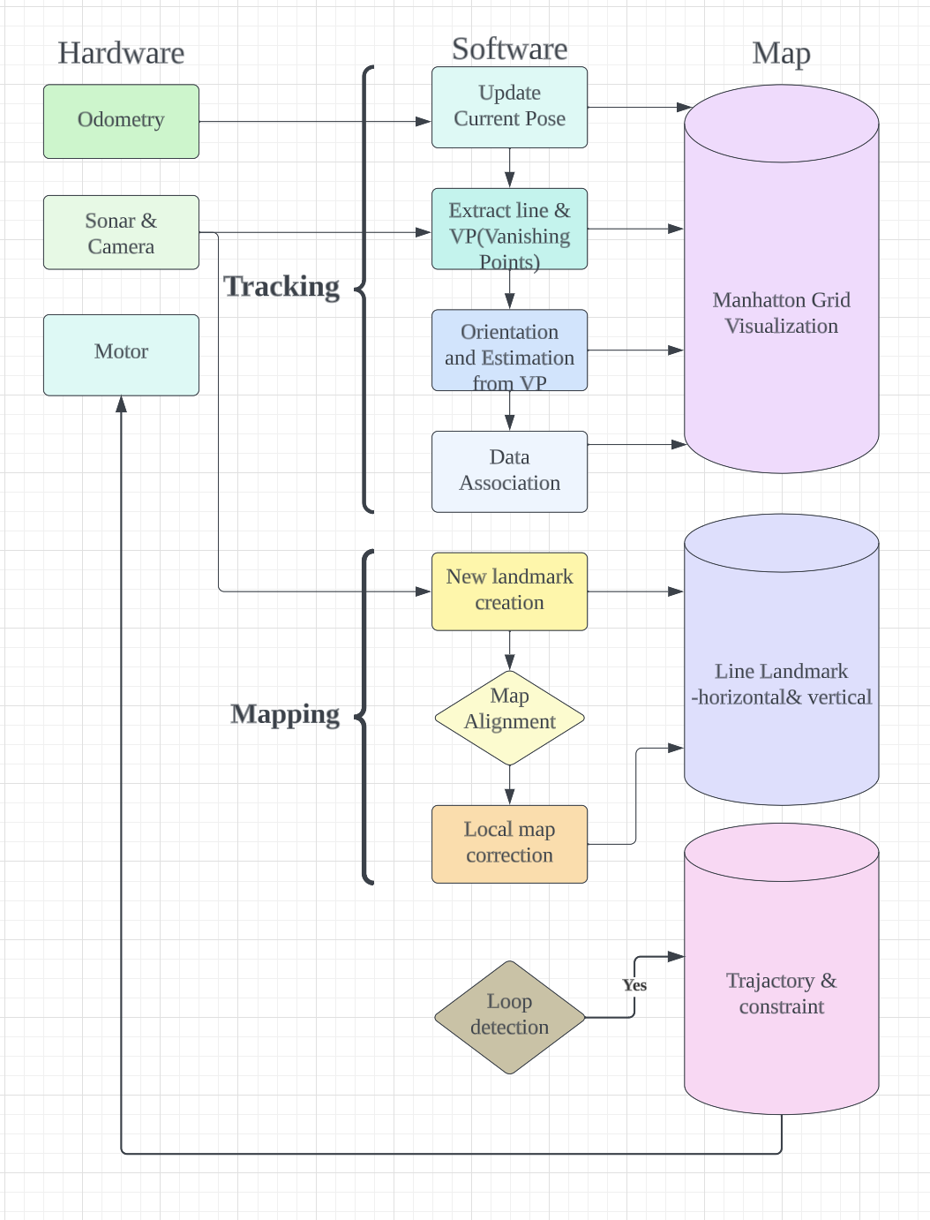

*Figure 1.1 A general hardware-to-software flow diagram showing how the vehicle and the program cooperate and retrieve position information. From the Odometry sensor, we get to update the current position, and from the sonar system, we can extract information about lines and VP(vanishing points). Next, we associate all the information to form a Manhattan Grid Visualization of the current environment. Also, the program leverages sonar to create new landmarks when moving forward. After that, it has to align the map with the current man to create a general view. Lastly, from the map correction, the software will have a clear view of line landmarks consisting information of their orientation relative to the coordinate system. [2]*

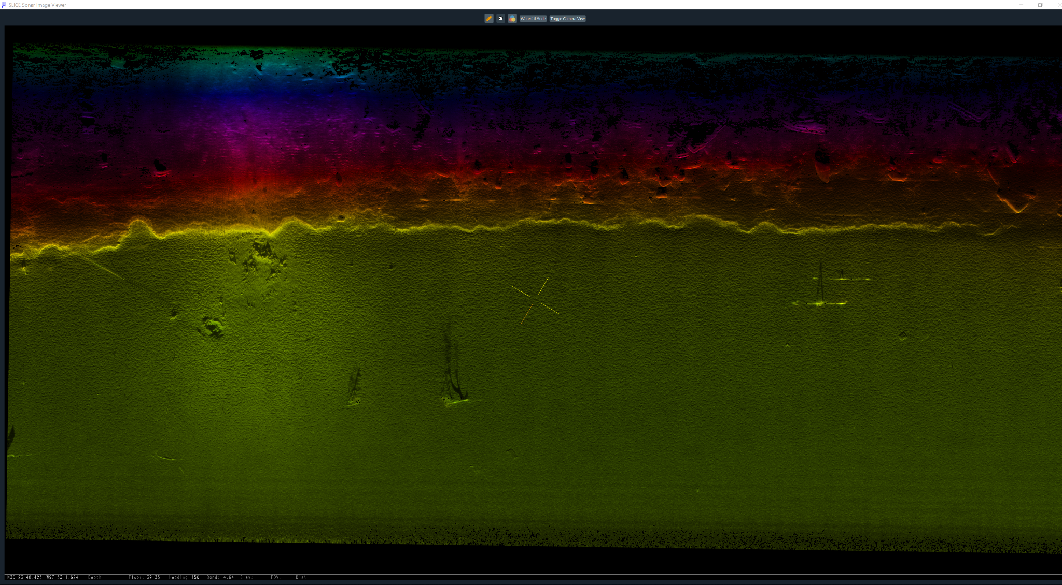

*Figure 1.2 The image would display a range of depth contours or isobaths, typically represented as color gradients. These contours indicate the varying depths of the sea bed, allowing viewers to discern the deeper and shallower areas. Deeper regions are often depicted in darker shades, while shallower parts are lighter. The sea bed image may reveal various bathymetric features such as trenches, canyons, ridges, seamounts, and underwater mountains. These features are displayed as distinctive, irregular shapes with varying shades, helping to highlight their topography and depth. Sediment Sonar images can distinguish different types of sediments on the seafloor. Sand, mud, gravel, and rocky substrates would each have unique textures and shades, with fine sediments like mud appearing smoother and lighter in color compared to coarser materials. The software can create a set of landmarks based on that information.* [1]

**4 Competing Technologies - Lu**

Since this is a new approach for the SLAM algorithms, there are no competing technologies in the underwater world, but there are some applications on earth that can be used as a base for water.

**4.1 ORB\_SLAM**

A key study titled "ORB\_SLAM: A Versatile and Accurate Monocular SLAM System” [3] focuses on how Bundle Adjustment (BA) is used in real-time Visual Simultaneous Localization and Mapping (SLAM). It highlights the crucial requirements for achieving precise results in a real-time SLAM algorithm, which are: having a strong network setup, effective matching of features, tracking, and the ability to close loops accurately. The paper traces the development of BA from its early use in visual odometry and SLAM to the creation of the ORB-SLAM system, a significant breakthrough in monocular SLAM technology. The study also discusses important features of the ORB-SLAM system, such as its use of ORB features for all tasks, its capacity to work in large environments using graphs, and its reliable camera relocalization. The text emphasizes the importance of an automatic and robust starting process, along with a selective approach to selecting map points and keyframes, which enhances the system's ability to keep track of its location and operate for a long time.

**4.2 LSD-SLAM**

LSD-SLAM[4] is a method that uses a monochrome camera to perform real-time mapping and localization. It uses pattern recognition and the detection of unique features in images to make accurate estimations of position and orientation. This approach can be used to understand how it works, but underwater SLAM is more focused on ORB-SLAM.

**4.3 FastSLAM**

FastSLAM[5] is a probabilistic SLAM algorithm that uses a particle filter to estimate the posterior over the robot's path and the map of landmarks. Instead of maintaining a single estimate, FastSLAM maintains a set of particle hypotheses, each representing a possible robot path and map. These particles are updated based on sensor measurements. This approach is particularly useful for handling non-linear and multi-modal environments. FastSLAM is frequently used in environments with significant uncertainties and non-linearity, where the true path and map might have multiple possible solutions.

**4.4 Lidor SLAM**

Lidar-based SLAM[6] leverages laser range finders (lidar sensors) to build maps and estimate the robot's pose. Lidar sensors emit laser beams and measure the time it takes for the beams to bounce back from objects, allowing for the creation of detailed 2D or 3D maps. The SLAM algorithm processes these measurements to update the robot's pose and map. Lidar SLAM is commonly used in applications that require high-precision and accurate mapping, such as autonomous cars, drones, and mobile robots operating in various environments. Lidar sensors are especially effective for capturing detailed spatial information.

# 5 Engineering Requirement

Engineering requirements for C-SLAM are as follows:

1. The algorithm must accurately classify the correct landmarks by excluding living creatures or any moving objects based on the sonar data.

2. The ability to determine the vehicle's orientation when it passes through a landmark.

3. A precise prediction model will be constructed to update the vehicle’s location using position estimation made by measurements of the distances and angles of the vehicle to the landmarks.

4. The accuracy rate of the vehicle’s location prediction model should reach a minimum of 90%.

5. The sonar data can be integrated into a bathymetric chart and adjusted based on the position estimation of the vehicle’s location.

6. A system that can either provide an online navigational fix to the vehicle or correct the offline vehicle’s tracking history.

7. A 3D graph can be created to provide a visual depiction of topography and depth of the seafloor.

# 6 Appendix A References.

**6.1 Equations**

Robot State Estimation:

In SLAM, we estimate the robot's pose as a probability distribution over its state, often represented as a Gaussian distribution. This is known as the posterior probability distribution, denoted as P(X), where X represents the robot's pose.

P(X) = Gaussian Distribution

Here, μ\_X is the mean (average) pose estimate, and Σ\_X is the covariance matrix that represents the uncertainty in the pose estimate.

Landmark Position Estimation:

In SLAM, we also estimate the positions of landmarks in the environment. Each landmark's position is also represented as a probability distribution. Let's denote the position of the ith landmark as L\_i.

P(L_i) = Gaussian Distribution

Sensor Measurements:

The robot's sensors provide measurements, such as range (distance) and bearing (angle) to landmarks. These measurements are subject to noise, which is often modeled as Gaussian noise.**Measurement Model** [5]

Here, z\_i represents the measurement to the ith landmark, h(X, L\_i) is the predicted measurement based on the robot's pose and landmark position, and ε is the measurement noise.

Bayes' Filter for SLAM:

SLAM employs a recursive Bayesian filtering approach, similar to the Extended Kalman Filter. The key equations are the prediction step and the update step.

Prediction Step (Motion Model):

In the prediction step, we use the robot's control input (u) to update the robot's pose estimate based on its previous estimate

.Prediction Step[5]

Update Step (Measurement Model):

In the update step, we incorporate the sensor measurements to update the belief about the robot's pose and the landmarks' positions

Update Step[5]

Here, Z is a normalization constant.

**6.2 Appendix and References**

[1] Gratton, Mike, and Draper Laboratory. *Sonar data of sea bed*. 2023. Accessed 19 Oct. 2023.

[2] Lee, Taejae. “A Monocular Vision Sensor-Based Efficient Slam Method for Indoor ...” *Research Gate*, 2018, [www.researchgate.net/publication/324551566\_A\_Monocular\_Vision\_Sensor-Based\_Efficient\_SLAM\_Method\_for\_Indoor\_Service\_Robots](http://www.researchgate.net/publication/324551566_A_Monocular_Vision_Sensor-Based_Efficient_SLAM_Method_for_Indoor_Service_Robots)

[3] Mur-Artal, R., Montiel, J. M. M., & Tardós, J. D. (2015). ORB-SLAM: A Versatile and Accurate Monocular SLAM System. Retrieved from <https://courses.cs.washington.edu/courses/csep576/21au/resources/ORB-SLAM_A_Versatile_and_Accurate_Monocular_SLAM_System.pdf>

[4] Engel, J., Schöps, T., & Cremers, D. (2014). LSD-SLAM: Large-Scale Direct Monocular SLAM. In European Conference on Computer Vision (ECCV). Retrieved from <https://jakobengel.github.io/pdf/engel14eccv.pdf>

[5] M. Montemerlo, S. Becker, J. Becker, J. Bhat, H. Dahlkamp, D. Dolgov, S. Ettinger, D. Haehnel, T. Hilden, G. Hoffmann, B. Huhnke, et al., "FastSLAM: A Scalable Method for the Simultaneous Localization and Mapping Problem in Robotics," Proceedings of the AAAI National Conference on Artificial Intelligence, 2002.

[6] S. Thrun, W. Burgard, and D. Fox, "A Real-Time Algorithm for Mobile Robot Mapping with Applications to Multi-Robot and 3D Mapping," Proceedings of the IEEE International Conference on Robotics and Automation, 2000.

[7] Thrun, Sebastian, et al. “Probabilistic Robotics. Sebastian Thrun, Wolfram Burgard, and Dieter ...” IEEE Xplore, Arificial life, Apr. 2008, ieeexplore.ieee.org/document/6792214/.

**Spell Check Everything!!!! Spell checking does not correct grammatical errors, conceptual errors, or malapropisms (The manual was full of Eros.) You must read the document carefully even when it has been spell-checked.**